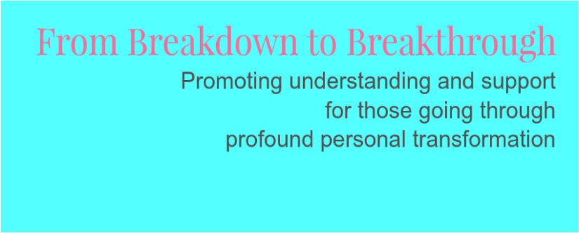

The Spiritual Crisis Network presents:

Release the potential within spiritual crisis
Honouring the Journey and Creating a Sharing, Caring, Containing Community.

8th October. 15.00 – 18.00.

Consciousness Healing Centre, Stroud

Where someone’s journey takes them to places of unusual, unshared experience, our society tends to label this as illness and shut it down as quickly as possible.
People having these experiences, which can be called spiritual crisis or emergency, do need a supportive, understanding, sympathetic community – to hold them through this process, keep them safe, and enable them to return to the shared world with renewed gifts and vision.
This event will present new, hopeful, ways of understanding this whole area of experience.
With this new vision, we will invite you, the participants;
- To share your experiences if you wish
- To think about how this containing community can be taken forward
- Time 15.00 - 18.00

Cost. £5 . For more information, email info@spiritualcrisisnetwork.uk
Speakers

Isabel Clarke
Mirabai Swingler
Trishia Cusson
Leigh Hunt

And you……..This is a participatory event!

